ALPHA BETA.
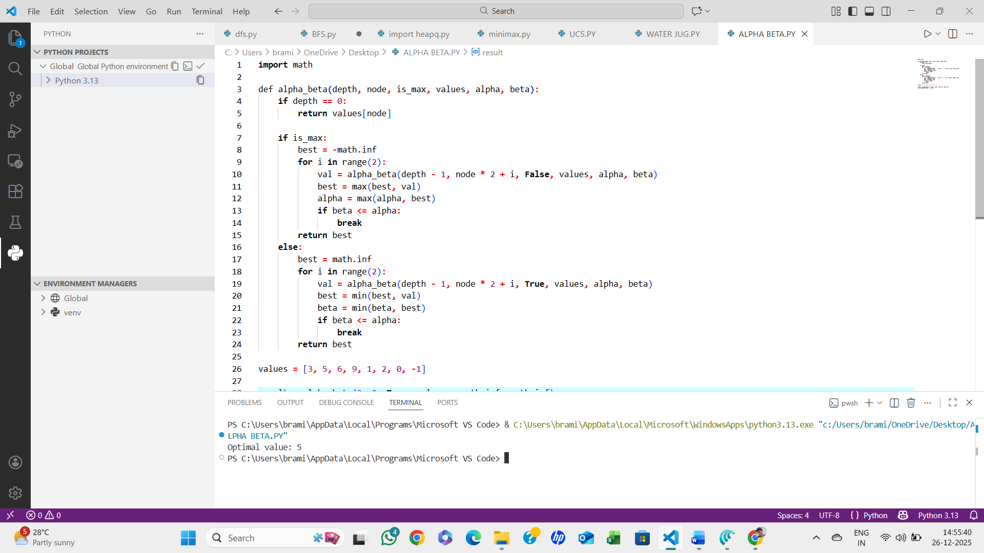

ALGORITHM:
- Start from the root node
- Maintain two values: alpha (best for MAX) and beta (best for MIN)
- Traverse the tree depth-first
- Update alpha and beta values
- Prune branches where alpha ≥ beta
- Return optimal value
- STOP.

